Chapter 9, Solution 32.

Using Fig. 9.40, design a problem to help other students to better understand phasor relationships for circuit elements.

Although there are many ways to work this problem, this is an example based on the same kind of problem asked in the third edition.

Problem

Two elements are connected in series as shown in Fig. 9.40.
If i = 12 cos (2t - 30°) A, find the element values.

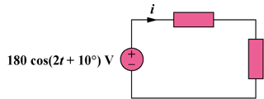

Figure 9.40

Solution

V = 18010, I = 12-30,  = 2

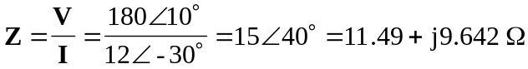

One element is a resistor with R = 11.49 .
The other element is an inductor with L = 9.642 or L = 4.821 H.

